Lab Number: | 4
Student Name: | Nitish Chavan
Roll No : | 18

Title:
4.1 Write a Java program to Create a class Student with two method getData() and printData(). getData() to get the value from the user and display the data in printData(). Create the two objects s1 ,s2 to declare and access the values from class StudentTest.
4.2 Write a Java program for Basic bank Management System

Learning Objective:
- Students will be able to write C++ and java program for using classes and objects.

Learning Outcome:
- Ability to execute a simple C++ and Java program by accepting and displaying values using functions
- Understanding the classes and objects concept in C++ and Java.

Course Outcome:
ECL304.1 | Understand object-oriented programming concepts and implement using C++ and Java

4.1 Write a Java program to Create a class Student with two method getData() and printData(). getData() to get the value from the user and display the data in printData(). Create the two objects s1 ,s2 to declare and access the values from class StudentTest.

import java.util.Scanner;
class Student {

Scanner in=new Scanner(System.in);
String name;
int roll_no;
float cgpa;
char div;
char branch;

void getdata()
{
System.out.println("Enter your name:");
name=in.next();
System.out.println("Enter your roll number:");
roll_no=in.nextInt();
System.out.println("Enter your CGPA:");
cgpa=in.nextFloat();
System.out.println("Enter your Division:");
div=in.next().charAt(0);
System.out.println("Enter branch:");
branch=in.next().charAt(0);

}

void getdata(String n,int r,float c,char d, char b)
{
name=n;
roll_no=r;
cgpa=c;
div=d;
branch=b;

}

void printdata()
{
System.out.println("Name of the student: "+name);
System.out.println("Roll-no of the student: "+roll_no);
System.out.println("Cgpa of the student: "+cgpa);
System.out.println("Division of the student: "+div);
System.out.println("branch of the student: "+branch);
}

};
public class StudentTest {

public static void main(String[] args) {

Student s1=new Student();
Student s2=new Student();
s1.getdata();
s1.printdata();
s2.getdata();
s2.printdata();

}

}
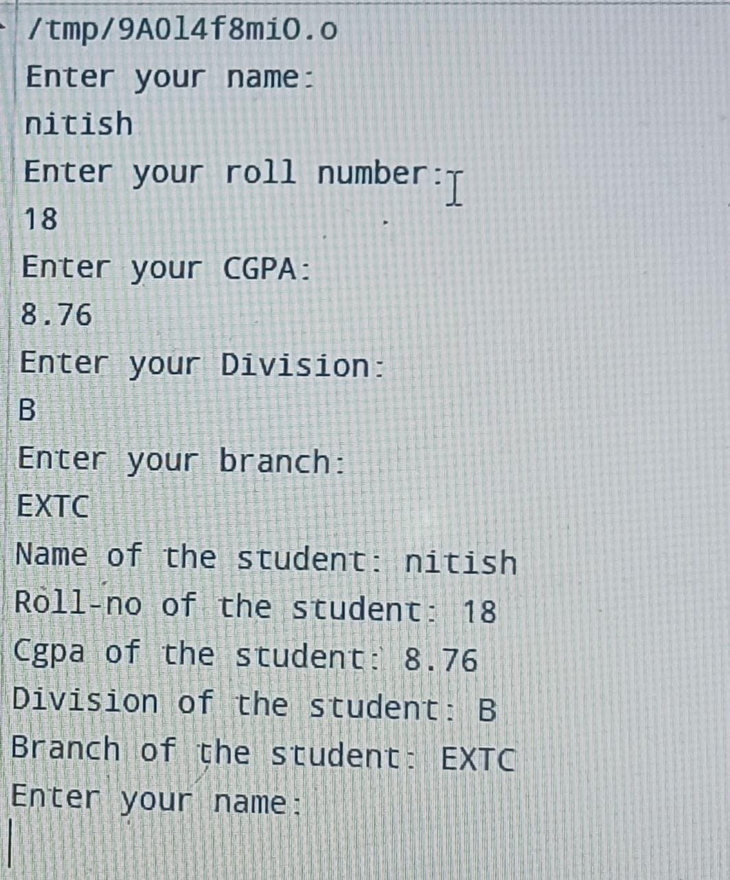

4.2 Write a Java program for Basic bank Management System
import java.util.Scanner;

public class BankLab2 {

Scanner in=new Scanner(System.in);

String name;

char account_type;

int account_number,amount;

float balance;

public BankLab2(String n,int a, char t, float b) {

// TODO Auto-generated constructor stub

name = n;

account_number=a;

account_type=t;

balance=b;

}

int deposit()

{

System.out.println("Enter the amount to deposit: ");

int amount=in.nextInt();

if(amount<0)

{

System.out.println("Invalid amount,Enter a valid amount");

return 0;

}

balance=balance+amount;

return 1;

}

int withdraw()

{

System.out.println("Your Balance= " +balance );

System.out.println("Enter amount to withdraw: ");

int amount=in.nextInt();

if (balance<amount)

{

System.out.println("Insufficient Balance: ");

return 0;

}

if(amount<0)

{

System.out.println("Invalid amount" );

return 0;

}

balance=balance-amount;

return 1;

}

void display()

{

System.out.println("Name :"+name);

System.out.println("Account Number:" +account_number);

System.out.println("Account Type:" +account_type);

System.out.println("Balance: " +balance);

}

public static void main(String[] args) {

// TODO Auto-generated method stub

Scanner in=new Scanner(System.in);

BankLab2 b1=new BankLab2("salman",1,'s',2000);

BankLab2 b2=new BankLab2("makarand",2,'s',2000);

BankLab2 b3=new BankLab2("siddharth",3,'s',2000);

System.out.println("Menu");

System.out.println("1.Deposit");

System.out.println("2.Withdraw");

System.out.println("3.Display");

System.out.println("Enter option");

int op=in.nextInt();

char ans;

do

{

System.out.println("Please enter your account number:");

int account_number=in.nextInt();

switch(account_number)

{

case 1: if(op==1)

b1.deposit();

if(op==2)

b1.withdraw();

if(op==3)

b1.display();

break;

case 2: if(op==1)

b2.deposit();

if(op==2)

b2.withdraw();

if(op==3)

b2.display();

break;

case 3: if(op==1)

b3.deposit();

if(op==2)

b3.withdraw();

if(op==3)

b3.display();

break;

default: System.out.println("Enter value between 1 to 3");

break;

}

System.out.println("Do you want to continue?[Y/N]");

ans=in.next().charAt(0); //char input in variable ans

if(ans=='Y' || ans == 'y')

{

System.out.println("Menu");

System.out.println("1.Deposit");

System.out.println("2.Withdraw");

System.out.println("3.Display");

System.out.println("Enter option");

op=in.nextInt();

}

}

while(ans!='N');

}

}

